**Steps to follow to Create DSN for Ms-Access DB:**

1. Create an access database **Employee.mdb** in any directory of your windows.
2. Open **start** 🡪 **control panel** 🡪**Performance and maintenance** 🡪 **Administrative Tools** 🡪Data sources (**ODBC**) 🡪 click **System DSN** tab 🡪 click **add**🡪 choose Microsoft Access Driver (*.**mdb**) > Provide the **datasource** name and click and browse the **Employee.mdb** located in your hard drive ) ->Click **OK**.

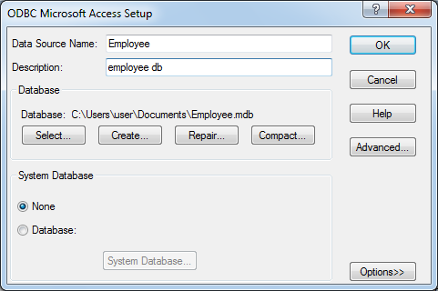

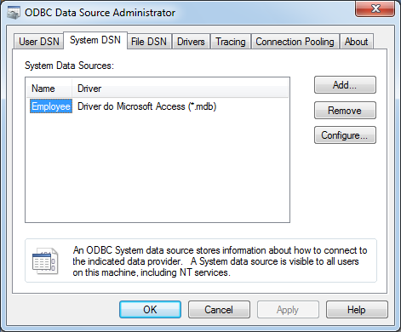

Click 🡪**OK**

**Reason: For ClassNotFoundException while connecting to MS-Access DB in Java 8**

java.lang.ClassNotFoundException: sun.jdbc.odbc.JdbcOdbcDriver exception in Java 8.

JDBC-ODBC bridge driver, it may not even be available even in 64-bit Windows versions. You will get this exception if you try to connect to Microsoft Access database from Java 8 JRE or JVM, because **JDBC-ODBC bridge driver is now removed**. Consider if you are using type 4 JDBC, pure Java driver with real database or if you still want to connect to MS access, use **Jackcess**library or a commercial driver like **HXTT**.

**To fix this issue, and also to use Microsoft Access database in JAVA add these extra JAR libraries.**  
1. hsqldb.jar   
2. jackcess 2.0.4.jar   
3. commons-lang-2.6.jar   
4. commons-logging-1.1.1.jar   
5. ucanaccess-2.0.8.jar

1. Download **ucanacess.rar** and extract the jar files in this location: <https://drive.google.com/file/d/0BxzPiTNQAcRCc09CcnZMQjdrRXc/view>

2. **Copy** all the jar files and paste in this java directory location **- C:\Program Files\Java\<Jdk-home>\jre\lib\ext**

**Simple JDBC Connection Steps using java**

1. **Register the driver class**

Connection c= DriverManager.getConnection"jdbc:ucanaccess://Path to your database i.e. MS Access Database.

**Class.forName(“driver_class”)** for other DB 🡪 dynamically load the driver class.

1. **Creating the Connection – to establish connection with the database.**

**Connection con= DriverManager.getConnection(url);**

1. **Creating Statement –** The createStatement() method of Connection interface is used to create statement. The object of statement is responsible to execute queries with the database.

**Statement statement = connection.createStatement();**

1. **Executing Queries – executeQuery()method of statement interface is used to execute queries to database.**

**ResultSet rs = statement.executeQuery("select * from Employee");**

1. **Closing the Connection – Close() method to close the DB connection.**

**Sample Code Snippet: Connecting to MS-Access DB using Java:**

|  |
| --- |
| **String url = "jdbc:ucanaccess://C:\\Users\\user\\Documents\\Table1.mdb";**  **try** {  // Class.forName("sun.jdbc.odbc.JdbcOdbcDriver"); --register driver while connecting to other databases.  Connection connection = DriverManager.*getConnection*(url);  System.out.println(“Connecting to database”);  Statement statement = connection.createStatement();  ResultSet rs = statement.executeQuery("select * from Employee");  **while** (rs.next()) {  **int** id = rs.getInt("ID");  String name = rs.getString("NAME");  String salary = rs.getString("SALARY");  String designation = rs.getString("DESIGNATION");  System.out.println(“ Retrieve details from database ”);  System.***out***.println(id + " " + name + " " + salary + " "+ designation);  }  } **catch** (Exception e) {  e.printStackTrace();  } |